Developing an FAQ Chatbot Using LangChain and LLM APIs
Student Name: Ismail Demirtas

1. Name and Purpose of the Chatbot
The chatbot I developed is called EchoAssist. EchoAssist is an FAQ chatbot designed to answer common questions about Amazon Echo and Alexa devices. The main purpose of this chatbot is to help users find quick answers about setup, troubleshooting, and general features. Instead of searching through long support pages, users can ask questions in natural language and receive clear responses. The chatbot uses official Amazon help content as its knowledge source, which helps make answers more reliable.

2. NLP / LLM Methods Used
This project uses a Retrieval-Augmented Generation (RAG) approach. First, user questions are converted into vector embeddings. These embeddings are compared with stored embeddings from the FAQ documents to find the most relevant text. Then, a Large Language Model (LLM) generates a response based only on that retrieved content.
LangChain is used to manage the workflow between document retrieval and response generation. Chroma is used as the vector database to store embeddings. An OpenAI language model is used to generate the final answers. This method was chosen because it reduces hallucinations and ensures answers come from real documentation instead of general model knowledge.

3. Dataset Information

3.1 Dataset Source
The dataset was created by scraping official Amazon support pages:
- Alexa and Alexa Device FAQs
- Amazon Echo Support Pages
These pages contain common user questions and answers related to Echo devices.

3.2 Number of Records
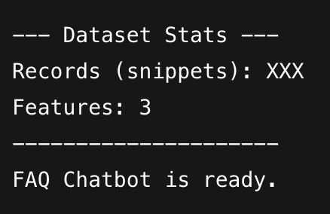

3.3 Number of Features

3.4 Description of Features
Feature Name | Description | Data Type
page_content | Extracted FAQ text | String
source | URL of the original page | String
tag | HTML tag type | String

3.5 Preprocessing Steps
- Removed scripts and styles from HTML
- Extracted headings and paragraph text
- Cleaned extra spaces
- Split text into smaller chunks
- Converted text into vector embeddings
- Stored embeddings in Chroma database

4. Libraries, Toolkits, and Frameworks
The following tools were used:
- Python – main programming language
- Requests – download web pages
- BeautifulSoup – extract text from HTML
- LangChain – manage prompts and retrieval
- Chroma – vector database
- OpenAI API – embeddings and LLM responses
Each library plays a role in building the retrieval and response pipeline.

5. Application Design and Implementation
First, the chatbot downloads FAQ pages from Amazon. The text is cleaned and split into small chunks. These chunks are converted into embeddings and stored in a Chroma vector database.
When a user asks a question, the system converts the question into an embedding and searches for similar FAQ chunks. The most relevant pieces of text are sent to the LLM along with the question. The LLM then generates an answer based only on that context.
This design helps the chatbot stay focused on real documentation.

6. Instructions for Running the Chatbot
- Install Python
- Install required libraries using pip
- Set the OPENAI_API_KEY environment variable
- Run the program using:
python chatbot.py
- Type questions in the terminal
- Type “exit” to quit

7. Results
The chatbot successfully answered questions such as:
- How Alexa uses voice recordings
- How to fix Wi-Fi setup problems
- What Alexa Voice ID is
The responses were usually accurate when the information existed in the dataset.

8. Discussion and Insights
Overall, the chatbot performed well for common FAQ questions. The RAG approach helped reduce incorrect answers because responses were based on official Amazon documentation.
However, there are some limitations. Sometimes the retrieved text was not perfectly relevant. Also, scraping web pages can include unnecessary content. Future improvements could include better cleaning, adding more official pages, and using reranking to improve retrieval quality.
This project helped me understand how NLP pipelines work in real applications and how LLMs can be combined with document search.

9. References (APA)
Amazon. (n.d.). Alexa and Alexa Device FAQs. Amazon Customer Service.
Amazon. (n.d.). Support for Amazon Echo. Amazon Customer Service.
Lewis, P., Perez, E., Piktus, A., Petroni, F., Karpukhin, V., Goyal, N., et al. (2020). Retrieval-augmented generation for knowledge-intensive NLP tasks. NeurIPS.
LangChain. (n.d.). Chroma integration documentation.
Meta AI. (n.d.). FAISS library.

